**Carolina Data Challenge Report:**

**By: Zhennan luo, Hao Wang, Daqi Chen, Trivikrama Sai .P.T**

For the data challenge, we, as a team of 4, decided work on the data set about the crimes in Chapel Hill. We thought that it gave us the opportunity to apply our working knowledge in data visualization with Tableau and machine learning (K-means Clustering shown below) with python. K-means clustering is an unsupervised learning algorithm that finds clusters in a given data set

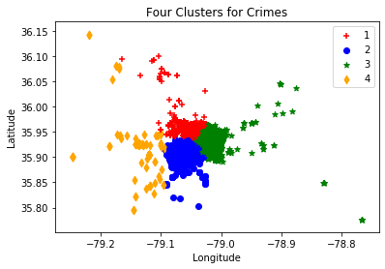.

We found that the data sets presented to us answered questions about the relations between when and where a crime was committed. We also used external data sets about residential areas CCTV locations and Adjusted Gross Income based on data from the IRS in Chapel Hill. From this we could conclude that Crimes usually take place in around highly populated residential areas and that the CCTVs are in fact in place to capture some of the crimes that take place in one of the 4 clusters (Downtown Chapel Hill). We also used Tableau to visualize if there existed a relationship between the AGI and the decreasing crime rates from 2010 to 2016; however, even though the crime rates decreased with an increase in Income, the change was slight and was not significant enough to come to a conclusion.